**DESIGN DOCUMENT**

Major steps for socket programming :

Server Side: 1) Creating a socket with the socket().

2) Binding the socket to an address using the bind ().

3) Sending and receiving the data using the recvfrom() and sendto() system calls.

Client side: 1) Creating a socket with the socket().

2) Sending and receiving the data using the recvfrom() and sendto() system calls.

Class and API’s and functions used in the code:

1. sock = socket(AF_INET,SOCK_DGRAM,0);

This call results in a datagram socket. The UDP protocol provides underlying communication.

1. AF_INET

Internet Family for IPV4

1. gethostbyname

This function returns a structure for the given host name

1. sendto

This function is used to send a message to another socket when the sockets are connected to each other

1. recvfrom

This function is used to receive the message sent by the another socket with which it is communicating.

1. Htons

This API converts an input to the hexadecimal value

1. Bzero

This API clears the buffer. It is very important to clear the buffer because it may store some junk value.

**SCREENSHOTS DISPLAYING THE WORKING OF PHASE 1**

**Client and server program:**

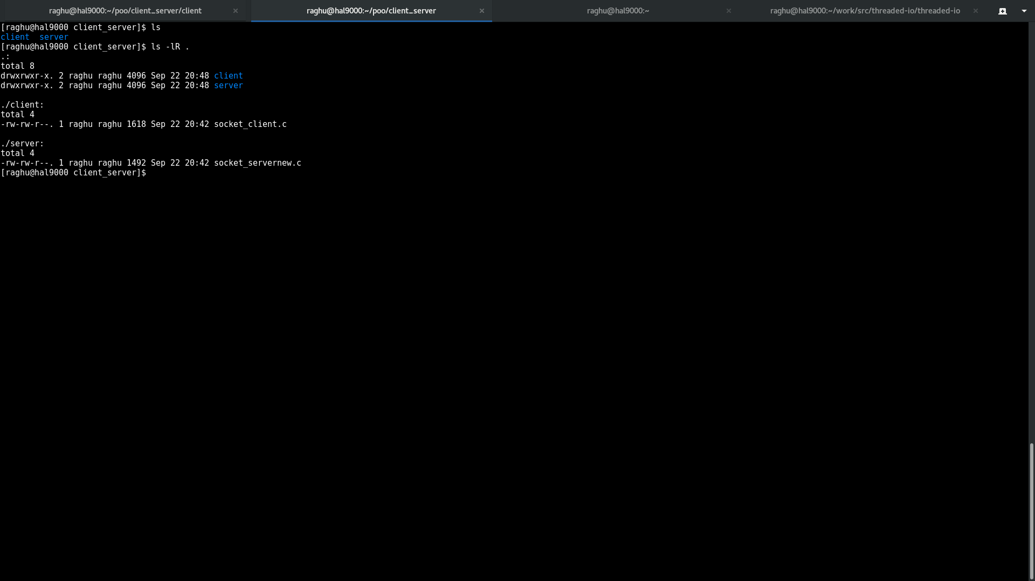

**Server compilation**

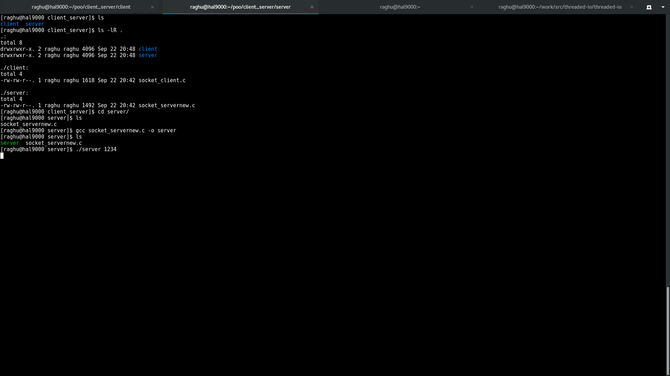

**Client compilation:**

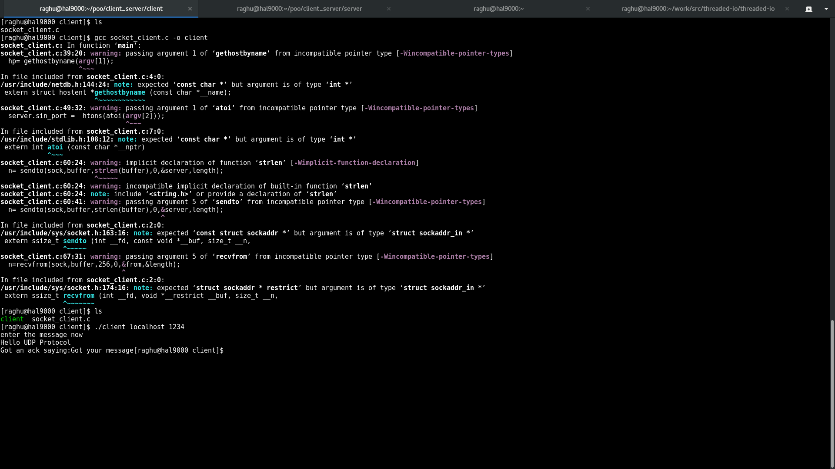

**Final output:**

